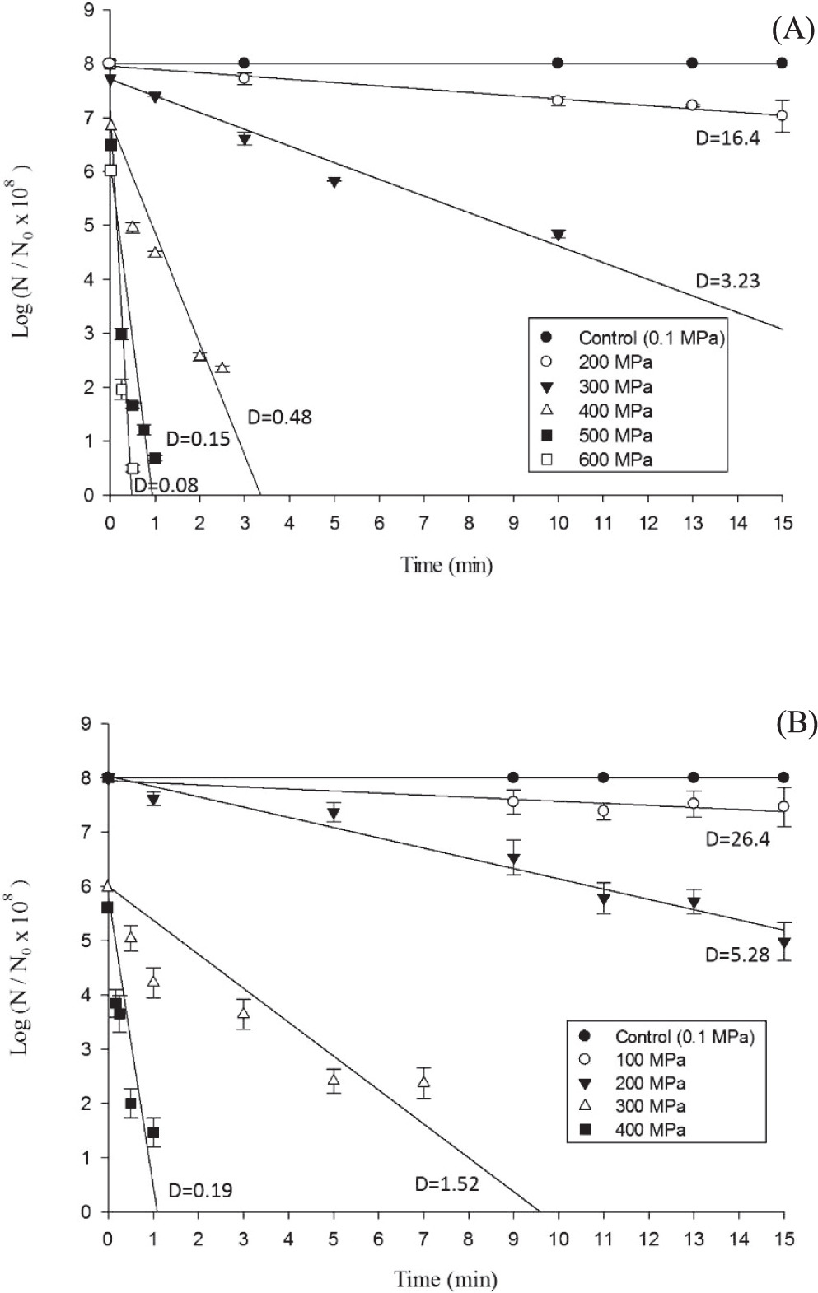
Supplementary Fig. 1 HHP survival curves of M. morganii treated with 200 to 600 MPa for up to 15 min (A) and P. phosphoreum treated with 100 to 400 MPa for up to 15 min (B) in phosphate buffer. Lee Y-C et al. Journal of Food Protection (2020) 83: 621-627.

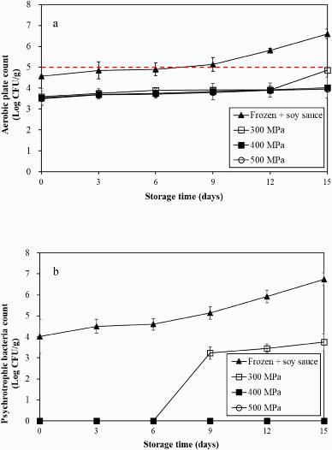
Supplementary Fig. 2 Changes of aerobic plate count (a) and psychrotrophic bacteria count (b) in freshwater clams frozen and then marinated with soy sauce, and marinated with soy sauce and pressurized under 300, 400 and 500 MPa for 3 min during storage at 4℃. Each value represents mean±SD of three replicates. Dash line represents 5.0 log CFU/g of APC as the regulatory standard for raw ready to eat seafood (Taiwan Food and Drug Administration, 1998) Wei et al. (2023) Food Control 154, 109999

